January 11, 2021 CIT Mentor Forum

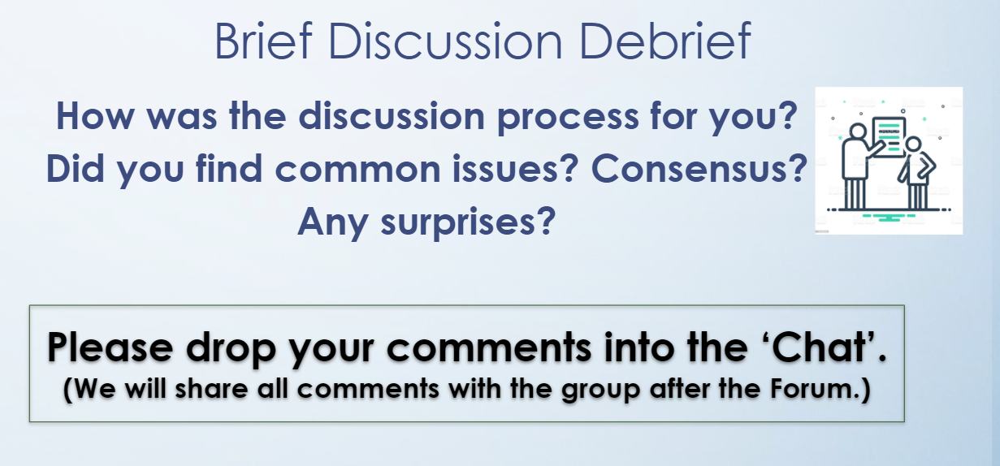

16:54:23 From Mariana Barry : more time needed!!!!

16:54:31 From Mariana Barry : it was a great discussion!

16:54:34 From Dianna.Speranza : Our group ROCKED it!

16:54:36 From sandy Perez : we needed more time

16:54:38 From Audrey Korokeyi : more time

16:54:38 From Amanda Forkner : we had a lot of similar ideas and definitely came to consensus on plan of action

16:54:40 From Leslie Grant : good conversation, collaboration

16:54:41 From Paula Riexinger : Needed a bit more time. Great conversation

16:54:43 From Tammy.Shaw@RCSDK12.org : very productive and collaborative!

16:54:44 From Regina Maier_Art : it was good to be in new groups

16:54:46 From Tracey Barnwell : great discussion

16:54:51 From Michele Michel : Good discussion.

16:54:51 From JOHN.DEGRANDIS@RCSDK12.ORG : WE all pretty much agreed and zeroed in on the questioning as something we wanted to discuss further with the intern.

16:54:52 From LIB_Susan Reuter : we all had similar observations

16:54:54 From Mariana Barry : yes great to meet new people!

16:54:55 From PREK Pamela Watson-Breedlove : the mixture of levels was great!

16:54:55 From Nicole Robinson : we had similar ideas great group :)

16:54:58 From MUS_Alison Schmitt : Padlet was a great platform for this

16:54:59 From Martha.Morales-McBride@RCSDK12.org : We had good discussion. We had were on the same page.

16:54:59 From Sue DeFabbia : I liked being in a group with new people.

16:55:00 From Alicia.Cheng@RCSDK12.ORG : I always learn so much during these convos

16:55:01 From CASSANDRA DEARRING : Our team rocked...

16:55:03 From Lynn O'Brien : group too small

16:55:04 From Tamara Sheppard : good processing

16:55:04 From Patti Greco : it was a positive discussion and experience

16:55:05 From sandy Perez : This process was better than the last one.

16:55:05 From Lisa Barnett : definitely needed more time

16:55:07 From Sarah Yasses : Our group worked well and I think we had enough time. It was nice to meet new people.

16:55:07 From SUSAN.RUDY@RCSDK12.ORG : a lot of consensus - good discussion

16:55:07 From LIB_Susan Reuter : we thought that part of the lesson was missing though

16:55:10 From Michael Brundage : this process seemed much smoother than the "sea sick" one

16:55:10 From Jamie.Miner@RCSDK12.ORG : we were all on the same page with our observations and post-conference questions

16:55:13 From Danielle Wingo. PE : had a great discussion with our group where many offered different vantage points that didn’t dawn on the rest of us

16:55:14 From Cheril Passamonte : we all had similar ideas and good discussion

16:55:15 From Kristine Elliott : Good to be in new groups. Good discussion.

16:55:15 From Melanie.Gockley@rcsdk12.org : good thoughts and worked well together

16:55:20 From Lieselle Taylor : I enjoyed the different perspectives.

16:55:28 From Gloribel Arvelo-Park (She/Her) : Good discussion, we were in agreement

16:55:28 From Karen.Chona@RCSDK12.ORG : liked the groupings being diverse in their backgrounds different perspectives

16:55:35 From Lori Laloggia : heard things I hadn’t considered

16:55:47 From sandy Perez : i liked that we listened to everyone's thoughts and selected the question that stood out the most.

16:55:50 From James Lukens-English : I enjoy hearing from different people.

16:55:56 From Jennifer.Buckley@RCSDK12.ORG : Very nice to meet and get perspectives from new people. We had similar observations and it was great to hear each other's thoughts

16:56:10 From Sonja Griffin : Great discussions on next steps!

16:57:09 From Tammy.Shaw@RCSDK12.org : It's great talking to dedicated professionals!

17:01:06 From Kathryn Arzuaga : Go BILLS!!!!

17:01:09 From Audrey Korokeyi : Thank you

17:01:26 From Annamaria Manso : Thanks for the chat my break out group 11!!

17:01:51 From Philip Konecny to STEFAN COHEN(Privately) : Well done...i am leaving encouraged.

17:02:01 From Mariana Barry : Thank you!!

17:02:04 From Alicia.Cheng@RCSDK12.ORG : Thank you this was helpful

17:02:12 From Tracey Barnwell : Thank you, Annamaria Manso

17:02:39 From Audrey Korokeyi : Very helpful